Initial Reality: A location aware strategy game

Tian Li, Nate Hansen
Department of Computer Science and Engineering¹
University of Washington, Seattle, WA
{tianfl, nhansen}@cs.washington.edu

ABSTRACT

The field of video games contains some of the most creative designs among commercial products that integrate software design with hardware capabilities. Some games are designed from an abstract idea, with brand new hardware created to make that idea come true. Such games include virtual shooting games with guns or Dance-Dance Revolution with a jukebox and foot-pad created to let users experience a real world sensation. On the other hand, some game designers create ideas that make use of existing technology in a new way. For example, Doom was one of the first multiplayer games ever created with idea of multiplayer in mind. It came in the 90’s, when the internet was first becoming accessible to average consumers. Another more recent example would be the Korean games that are based around Bluetooth capabilities in cell phones. Phone users can run programs on their cell phone will automatically create connections with other users via Bluetooth (a networking protocol which became popular just recently). Bluetooth was not created to play games, but the designers found a way to fit this exciting new technology into their program to create an innovative form of entertainment. In this paper, we describe the design and implementation of Initial Reality, a game we designed using two existing hardware oriented technologies: Bluetooth communication and PlaceLab (a location aware system that uses WiFi) in order to bring a new type of strategy game and the potential it may have in the future.

INTRODUCTION

In essence, Bluetooth allows mobile devices to detect each other and exchange information. This simple yet promising ability has led to its recent rise in popularity. We are seeing a trend where mobile devices, ranging from phones and IPAQ to automobiles, are being equipped with Bluetooth capability. Among the different types of applications developed on top of the Bluetooth stack, games have been tried various times. The ability to exchange state information easily and the fact that devices such as phones and IPAQ are evolving to point where they can handle graphic and processing demands of well optimized games indeed makes such attempts achievable.

The number of Wireless devices is growing at a high rate. By detecting WiFi (802.11) “hotspots” in the region, you can establish a good estimate of your absolute location. The PlaceLab package developed by Intel Research Seattle, written in Java provides these exact features. Most role play games are based on the fact the player has to explore a carefully crafted virtual world. Many different people have attempted to make this world more real using things such as 3d graphics and virtual simulation. With our game running on a mobile device, and the power of PlaceLab in hand, we attempt to tackle this problem of achieving realism in a different way. By programming key locations into the real world, the user has to physically be present at various locations in order to trigger events in order to progress through the game.

A few similar attempts at experimenting with new features in games that runs on mobile devices exist today. They will be mentioned in detail in the related work section below. Briefly, they mostly consists of information exchange via short distance networking protocols such as Bluetooth, and some sort of agent behavior that while each unit runs a simple algorithm, many people running the same game as a whole makes it a fun experience. Massive Multiplayer Online Role Playing Game (MMORPG) theory states that the successfulness of a multiplayer game is directly proportional to the amount of users it can attract long term.

Initial Reality is our attempt to use the most modern technology to achieve a new level of realism in role playing games. Using peer to peer Bluetooth communication and PlaceLab, we hope our game will bring video gaming into the real world, the more people that play, the better it will be.

EXISTING WORK

Our game in essence incorporates three key ideas: passive game play, location awareness, and Bluetooth communication. Although we did not find anything close enough to use on a lower level, we did find a few games that we used to draw general ideas from. Specifically, we found 3 games, all offering a different type of gaming environment and technology for us to think about.

The first I don’t really consider a “game” but rather more of an idea based on a technology. The thing I speak of is the British phenomenon called “Toothing”. Toothing developed as a way for people in Britain to pass the time while riding on the train or bus. Many people ride busses and trains in Britain, so the popularity of this game is very high there. Toothing is basically just text messaging, just like we have all done at some point with own our phones. There are two main differences though. One is that it is anonymous; there is no record of who sent you the message. The second is that it uses Bluetooth radio for sending the message instead of the regular phone network (that’s how it is anonymous). This also means that you have to be within the short range that Bluetooth is capable of transmitting (on the order of tens of meters). People usually ride same train home from work every day, so they would develop Toothing relationships with people. This Toothing relationship would lead to other forms of entertainment for the Toothing pair if all went well. The idea of Toothing gave us a starting point for our game. The idea of using Bluetooth enabled devices for a real life game with other players. The game idea of Toothing is not really what we were going for though.

The second game is called “Pac-Manhattan”. This game was created by a group at NYU. More information can be found at http://pacmanhattan.com. This is a game that takes place in Washington Square Park in New York. Five people dress up as Pac-man, and 4 ghosts: Inky, Blinky, Pinky, and Clyde.
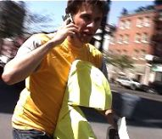
Shot of someone playing Pac-Manhattan
They run around the game grid and relay their positions to 5 other players in the control room. The controllers have a grip and they update the location of each player. There is one controller per player and they advise the players what to do while following a few basic rules of the game. Pac-man is trying to collect virtual pellets and the ghosts are trying to catch him. Although this game doesn’t really use much technology (they are just talking on cell phones), the idea of a live multiplayer game in the real word is something that gave us inspiration. Also we used the fact that they mapped out a real area in the city and turned it into a virtual game world that the players moved through. This is just like how we map out the UW campus into a virtual world that players move through and interact with.

The third game that we drew from is called “Can You See Me Now?” It was developed through a collaborative effort from Blast Theory, Mixed Reality Lab, and The Equator Interdisciplinary Research Collaboration. More information can be found at http://www.canyouseemenow.co.uk. This game combine’s online multiplayer activity with real world real time gaming. There are a number of online players and a number of “runners” in the real world carrying computers with GPS systems.

Shot of someone playing CAN YOU SEE ME NOW?
The position of the runners is updated to the online line players through the GPS coordinates. The online players try to catch the runners. The runners can see where the online players are on their computers and try to avoid being caught. This game also shows that you can turn a real environment into a gaming environment. They use a passive way to locate players unlike Pac-Manhattan where you had to relay your location on the phone. In Can You See Me Now, they use GPS; we decided that PlaceLab would be a good way to accomplish the same passive location aware system in our game. That is, a way to place a player in the game world without the need for the player to do anything.

You can see that we found many games that share a similar idea of bringing games into the real world using modern technology. Unfortunately, none of these games were close enough to what we wanted to actually use any of them to help us develop our game, and none of them are open source anyway. This leaves us to fend for ourselves in the development department.

APPROACH

Since we were unable to find any open source references to help us base our game design on, we had to come up with everything on our own. We had an idea of what we wanted the game to do, so we had to then figure out how to use the technology available to accomplish what we wanted. This is easier said than done.

Our fist idea was to use the Intel Personal Server to store the game code because it has Bluetooth and WiFi capabilities. The idea was to have the game running on the personal server and at the end of your day, you could link into your PC and check the status. We decided not to do this because the user has no feedback from the personal server throughout the day. The user is basically playing in the dark and has no way of making any type of game strategy.

We decided to look at the IPAQ next. The IPAQ is capable of Bluetooth communication as well as WiFi. Also, it has a great user interface. So we went ahead and used the IPAQ. The next decision was what OS to run on the IPAQ. We had two choices, PocketPC or Linux. Linux would be easier to use because it runs almost the same as we are used to running on the CSE servers. The problem lies with trying to create a fun GUI for the game. This led us to the decision to use Windows CE (PocketPC). Which allowed us to use a graphics package called SWT, more information on SWT can be found at http://www.swt-designer.com/. PlaceLab is very stable on windows CE so that was also a bonus.

We also though about using a Bluetooth equipped cell phone. They have the ability to communicate with Bluetooth, but PlaceLab is not available for the cell phone at this time so it was not feasible option.

Our game has one major hardware component and 3 major software components. The hardware is obviously the IPAQ. The Three major software components are the game logic and GUI, the PlaceLab package and Bluetooth communication.

There were many things that we had to do to approach this project. We had to get familiar with the windows CE environment first. This consisted of getting the wireless card working and the Bluetooth enabled. Then we had to learn how to run compile and run java programs using J9 on the IPAQ. This is a little different than running java programs in a command line environment because windows CE has no command line interface. To do this, you have to compile the code with J9 to run on windows CE, then set up an .lnk file to run the program with the correct path variables and arguments.

Next we had to get PlaceLab running. This went hand in hand with learning how to make basic java programs run. First, the PlaceLab package was installed on the IPAQ. Then we got familiar with it by reading the code and running some simple sample applications included in the PlaceLab package. Once we got PlaceLab running, we created some of our own simple applications similar to the ones provided, the difference was that all the provided samples just ran off log files whereas we need to get real time feedback from the WiFi card and figure out where our current position is.

Lastly we went about implementing the P2P Bluetooth communication. This is where the lack of open source examples really hurt. We later found out why there were none. At this time windows CE does not provide an API for Bluetooth. So this created a problem.

IMPLEMENTATION

The hardest part of getting things to work was leaning how to develop on an unknown platform (windows CE). This created many challenges for us. Challenges included running java programs using “links” (.lnk files) and J9, as well as getting PlaceLab to run and Bluetooth working.

PlaceLab only runs on window CE version 2003. This was not information that was made readily available to us. Because of this, it took longer than necessary to get PlaceLab up and running. We spent long hours trying to debug endless java error messages when trying to run PlaceLab on the older version of the OS. Finally someone asked the simple questing “you are running windows 2003 aren’t you?” So that was one setback.

We had many choices to make when implementing this game. One choice which turned out to create the biggest tradeoff was choosing to use window CE instead of Linux. This gave us the ability to create a better GUI. Also, I think that this gives the game more appeal because there are more people that run windows on the IPAQ than there are Linux users. The tradeoff lies in the fact that there is no java API for Bluetooth with this OS. This led us to use an open source program called “Harold” (www.something.com). We were able to get Harold running on the PC in a few hours. Harold requires javacomm to be installed to work correctly. Because of this (and probably other reasons), it was harder to get Harold running properly on the IPAQ. We were never able to get Harold to work with the IPAQ.

Because we couldn’t get this important piece to work, we decided to spend the time to make a nice GUI. Also, we took the game logic to the next level. Hopefully there will be an API for Windows CE soon so someone can finish the Bluetooth part of this game. Without it, the game is still very functional though. If you think about it, all role playing games are made for one player. The character just deals with all virtual characters. To compensate, we decided to include some game characters in our game world. To encounter a character, we just added them to the PlaceLab Event class. This means that they are triggered when PlaceLab tells the game logic that your character is near one of the virtual characters.

Learning an entirely new [to us] API for graphics was no easy thing in itself either. We were able to follow some tutorials from the SWT homepage to help get us up to speed. As the interface became more familiar to us, we were able to do more and more with it. For someone to try to pick this project up from here, all they would have to do is have a basic understanding of java and read through a few SWT tutorials. The rest would be just learning about run java programs on the IPAQ and leaning how PlaceLab works.

EVALUATION

Overall the game works well. The fact that we were able to make it graphical instead of just a text output makes the game a success. There are features that need to be added before this game could hit the market but I think we have succeeded in creating a great starting point for another group to take it to the next level.

The biggest question for any game designer is this: is it fun? I think that we succeeded in this aspect. The game didn’t come as far as we would have liked. From our original scenario, we lack one key aspect but we have also added to the original scenario in other areas. In the original scenario, we wanted to create a fun, multiplayer, location aware game. We wanted something that a future game designer could use as the underlying logic of a game. This would leave him to concentrate on making a larger virtual world with better graphics. Two out of three of those original metrics, we succeeded and surpasses our original goals. And in one, we failed to meet it. Because we couldn’t get P2P Bluetooth working, we are left with a single player game. Rest assured though, the game is fun to play, it succeeds in creating a gaming environment in the real world. And it is very easy to use and enjoy due to the fact that there is a simple GUI to equip your character and set up your strategy.

CONCLUSION AND FUTURE WORK

At this point I’m sure it is clear what the next step to take should be: Get Bluetooth working. Once a Bluetooth API for windows CE is developed,
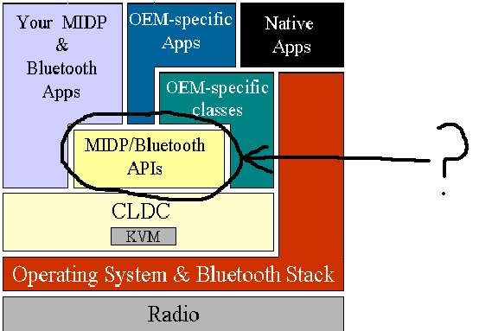
The missing layer

Initial Reality could utilize this to become a complete multiplayer location aware role playing game. Also, there is always room to improve the graphics in any game. That is the reason that there are over 10 versions of the popular role playing game “Final Fantasy”. Each new release comes with better graphics and a larger world. Every time a company releases a new game playing system with better capabilities, the gaming companies make changes to their game to utilize the new graphical abilities of the current system. At this point, we are no where near the graphical limits of the IPAQ, which means there is room for improvement. And when faster and better IPAQS come out, there will be even more room for improvement. There is also always room to make the gaming environment larger. As PlaceLab gets more precise and spreads out to cover larger regions, the game world can also be expanded. As of now, Initial Reality only uses the UW campus for its gaming world. We have not yet maxed out the current limits of PlaceLab. And PlaceLab is growing so there will always be more to add. The logic and story of a video game can also always be expanded to make the game more interesting.

Creating a video game is a big challenge. We had to mix several different current technologies to create a fun and new game. This forced us to learn how to use technologies that were new to us. The more things that you try to incorporate into a project, the harder it becomes. Trying to get Bluetooth working proved to be impossible with the components we chose to use. What we learned from creating Initial Reality is that it is hard to make many different components work together to produce a single goal.

If we were put in a time machine and sent back to the beginning of the quarter knowing what we know now, there are a few things that we would have done differently. For starters we would have been able to get PlaceLab working much faster enabling us to spend time on other aspects of the game. Also, we would have saved a lot of time with Bluetooth because we now know it can’t work with windows CE. Given all this time that we would have saved, maybe we could have come up with a way to make the game multiplayer without using Bluetooth. One way might be to send information about our current position to a central website that could compare our position to that of others playing the game. Basically we learned that it comes down to one rule. It takes a lot of time and effort to create interesting projects.

ACKNOWLEDGEMENTS

This quarter there were several people that helped us in creating Initial Reality. The TA’s for 477 helped a lot. Waylon was always there to help out. He worked hard to get us the hardware we needed. When we figured out why PlaceLab wasn’t working, he got us 2 new IPAQS in just a few days. This was really important because we didn’t learn this until there were just a few weeks left in the quarter. Alan also helped us a lot. He spent a lot of time helping us get PlaceLab running by coordinating with the people at Intel Research Seattle, who I would also like to thank. Besides that, Alan showed us where to get started learning how to work with J9 on the IPAQ.

REFERENCES

Related work:

Can You See Me Now? game
http://www.canyouseemenow.co.uk/

Pac-Manhattan game
http://pacmanhattan.com/index.php

A blog about the British phenomenon “Toothing”
http://toothing.blogspot.com/

Technological resources:

PlaceLab:
http://www.placelab.org/

Java Bluetooth article:
http://developers.sun.com/techtopics/mobility/midp/articles/bluetooth2/

Some Bluetooth development page:
http://www.benhui.net/bluetooth/tutorial_wtk2_nokiaS60.html

Harald, a Bluetooth stack
http://www.control.lth.se/~johane/harald/

A Bluetooth chat program (using VB)
http://www.devx.com/wireless/Article/11511/0/page/2

Appendices

Here is the basic Initial Reality sourcecode outline:
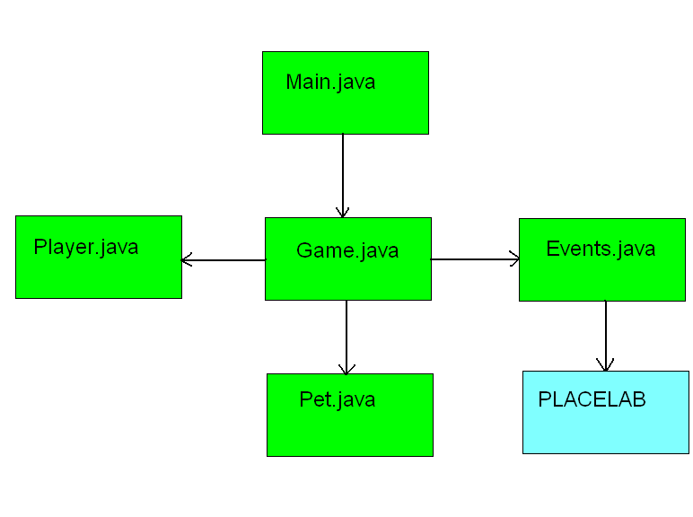

The source code can be found here:
http://www.cs.washington.edu/education/courses/cse477/CurrentQtr/projectwebs/cse477j/

A game world map overview:
